Emergency U-Turn

Emergency U-turns are really helpful behaviors to teach to reinforce loose leash walking and to use as an evasive maneuver with fearful or reactive dogs. If you can cue the dog to turn and move with you, the dog will not continue scanning the environment for the trigger, whatever it may be.

There are three different ways that you can teach this behavior and I suggest practicing all three.
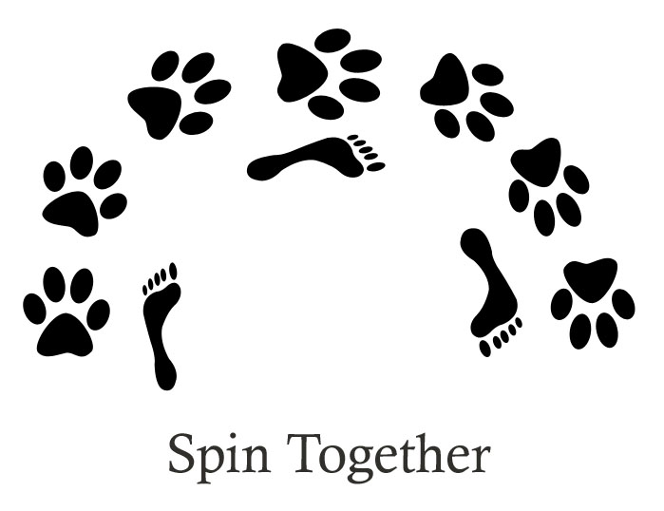
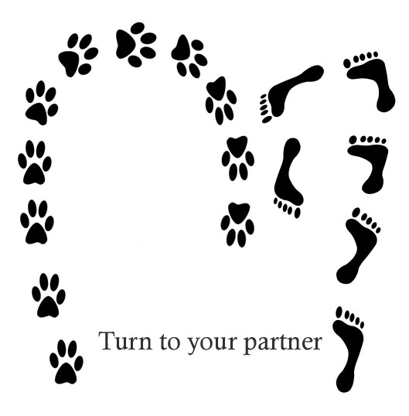
- Spin together—With Fido in heel position (either left or right side), you will say “this way” (or whatever cue you want to use), put a treat down in front of Fido’s nose and you will both turn together to face the other direction. Mark, “Yes” and release the treat when facing the opposite direction.
- Turn Toward each other—With Fido at heel, you will have a treat in the hand on the opposite side of the dog. You will say “this way” and turn towards Fido and put the hand with the treat right in front of Fido’s nose, and continue walking the opposite direction with Fido now on your other side then release the treat.
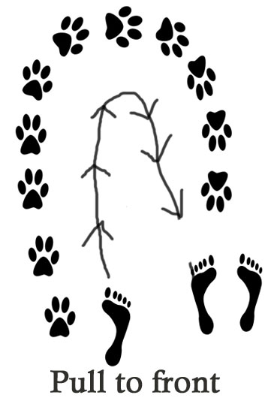
- Pull into front—With Fido at heel, you will cue “This way” and just reverse your direction (so walk straight backwards) and as Fido turns into “front” position, mark “Yes” and reward.

