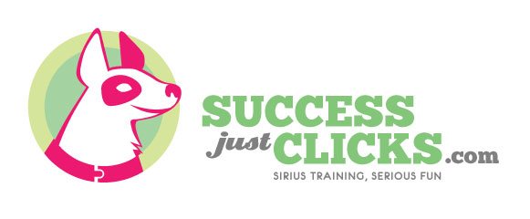

It’s Yer Choice/Leave It
I like to start teaching “Leave it” by first teaching dogs to make good choices in life by playing a game called It’s Yer Choice which allows dogs to make a choice and there are consequences (good and bad) for that choice. Through this, they learn to offer good choices instead of bad choices. Once they have a history of making good decisions I start adding the “Leave it” cue.

It’s Yer Choice—step 1
- Put treats in your closed fist and present them to your dog. They can paw, bite, nibble, lick, and chew your fist and NOTHING happens.
- The moment the dog backs away, looks away, or gives up, your hand opens exposing the treats.
- A) IF the dog immediately comes back toward your hand with the treats close your hands so the dog can’t get the treats and go back and wait for step 2.
B) IF the dog stays back for a second, you say “Yes!” and give them a treat from the had with all the treats (I don’t care WHY they aren’t going for the treats, the only criteria is not going for them.
- Repeat the process until your dog can see all the treats in your open hand and not try to get the treats. You’ll end up just feeding treats out of the palm of your open hand as long as the dog stays back (keep rewarding good choices!)
- When the hand game is easy-peasy, you’ll go on to step two of the It’s Yer Choice game where you repeat the process with treats on the floor under your hand. When Fido backs away, you flip up your hand exposing the treats. If Fido stays back, he gets a treat, if he comes close, the hand covers the food.

It’s Yer Choice Step 2:
- Place a pile of treats on the floor and immediately cover the pile with your hand. Fido can bite, nibble, chew, lick your hand but the ONLY thing that will cause your hand to pivot open is backing away.
- When Fido does ANYTHING that is NOT trying to get the food (looks away, backs, away, sniffs the ground, lays down, etc.), you will pivot your hand open. IF Fido stays back, say “YES!” and give Fido a treat from the pile. IF Fido comes close, simply close your hand and wait until he backs away again.
- Repeat the game with the treats under your hand until it is very easy for your dog to see the treats on the floor and not even try to get it
- To make this more difficult, you can try stacking up the treats, placing treats on your dog’s feet, or adding movement to the treats (dropping them from a VERY short height onto the pile—as there is success, slowly increase the height from which they are dropped.
- When this is simple with many variations in multiple environments, move on to step 3.
It’s Yer Choice Setp 3:
- Step three of IYC involves using the leash as a barrier for treats on the ground. Shorten the leash or have Fido restrained elsewhere while you put a pile of treats on the ground.
- Let Fido SNIFF the treats (not actually touch them, so you may want to start 5 or 6ft away). When Fido GIVES UP trying to get the treats, mark and reward: “Yes!” and treat. Repeat until Fido ignores the treats.
- When Fido is ignoring the treats, you can start taking moving around the pile(s) of treats. If Fido stops to investigate, STOP MOVING and wait for Fido to make a choice to leave it alone, then mark & reward.
- After the dog is easily and quickly turning away from a variety of values of bait on the floor, you can move on to adding the “Leave it”
- Go back to number 2 in this step but this time, AS Fido is turning his head away from the treats say, “Leave it” and then “Yes!” and a treat. Make sure you are saying “leave it” as they choose to turn away.
- After at least 4 sessions of #5’s, try saying “leave it” before they turn. If they turn to you, they are starting to understand, if not, do more #5s.

