Keys to Successful Tugging
(© SJC, Modified Blog 12/27/10)

When some dog owners play tug with their dog, they build and build the excitement level of the game and at the peak, they decide they want the tug back. To regain control of the game, they may start raising their voice (yelling “out!” “drop it!” “stop!!!”), tugging more desperately, grabbing their dog’s face or thumping the dog’s ribs with their hands…. unfortunately, to many dogs, within the context of the game of tug, these things are VERY fun and reinforcing actions.

Dogs learn that when they get out of control, their handlers get REALLY exciting and the dogs love this super fun game. So, the dogs learn to get completely out of control as a way to make their handlers get REALLY exciting and that’s dangerous. These dogs need to learn how to play tug appropriately and need to learn to control themselves. By following simple rules, the game of tug can be awesome for dog and human because it can build lots of self-control which is always a good thing. With the rules, it’s important to be consistent and start with games that aren’t as exciting.

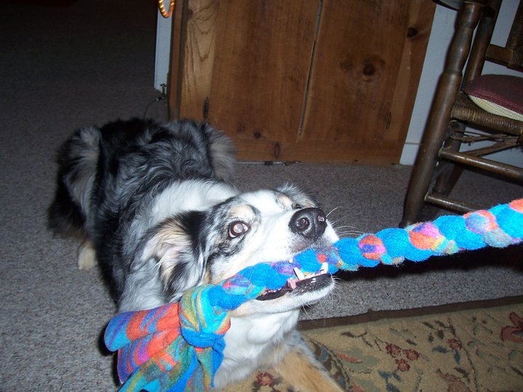
The Rules I use for successful tugging:
1. Humans start and end the game–If the pups are throwing tug toys in my lap, I do not automatically start tugging with them… the game is special and their solicitation does not mean I will tug with them—the game starts when I want to play, not when they are begging. The game always ends by cuing a “drop” and taking the toy and putting it away or dropping it on the ground.
2. Dogs earn the tug and ONLY tug when they are told to do so—the dog must earn the game by responding to a cue from the handler, sit/down/touch/etc. If the dog responds to the cue, the dog is then told to start the game with the magic words, “Get it!”. If the dog touches the tug before being told, the game stops for a minute & then cue the start behavior again before the magic words. Be strict with this rule and you can teach the dog to leave the toy alone even if it’s swinging.
3. Teeth on human skin ends the game immediately—I do not allow ANY teeth on skin during tug. If at any point a dog’s teeth touch my skin, I calmly end the game and will not play it for the rest of the day (the toy is removed). This rule may be the most important because it keeps people safe and makes sure dogs stay in control of their mouths. If the dog doesn’t learn good control, it’s a dangerous situation because as they get excited their mouths tend to get harder.
4. Not dropping the tug when cued will result in the end of the game *this rule is only introduced when the dog knows the “drop” cue. I start working “drop” at the very beginning of tug training. I start at lower excitement levels during the game and work up to asking for a “drop” at a high level of excitement. This is how I control the game—if the dogs are getting too crazy, I cue for a “drop,” then let things cool off for a few seconds before starting the game again (or ending it).

It’s okay for your dog to “win” the toy during the game sometimes. If the dog never wins, they eventually stop trying to play (if no one ever won the lottery, no one would play). As long as these rules are followed and the game is controlled, tug is a great game to play!

